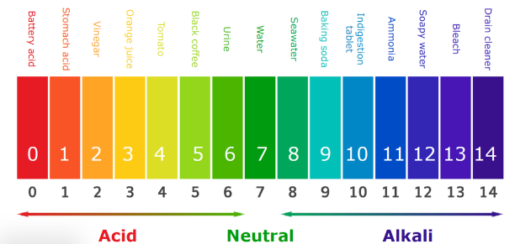

|  |  |  |  |  |  |  |  |  |
| --- | --- | --- | --- | --- | --- | --- | --- | --- |
| Science4Fun p68 ……Acids and Bases | | | | | | | | |
|  | Household  solution | Predict  Acid or base? | Red litmus  (blue = base) | Blue litmus  (red = acid) | Universal  Indicator  (colour) | pH scale  reading  (1-14) | Acid or base | observations |
| 1 | Distilled H2O |  |  |  |  |  |  |  |
| 2 | Toothpaste |  |  |  |  |  |  |  |
| 3 | Egg |  |  |  |  |  |  |  |
| 4 | Vinegar |  |  |  |  |  |  |  |
| 5 | Lemonade |  |  |  |  |  |  |  |
| 6 | Detergent |  |  |  |  |  |  |  |
| 7 | Apple juice |  |  |  |  |  |  |  |
| 8 | Gaviscon  antiacid |  |  |  |  |  |  |  |
| 9 | Bleach |  |  |  |  |  |  |  |
| 10 | Shampoo |  |  |  |  |  |  |  |
| 11 | Milk |  |  |  |  |  |  |  |